Ben Sottile

Beer Master Reverse Engineering Result

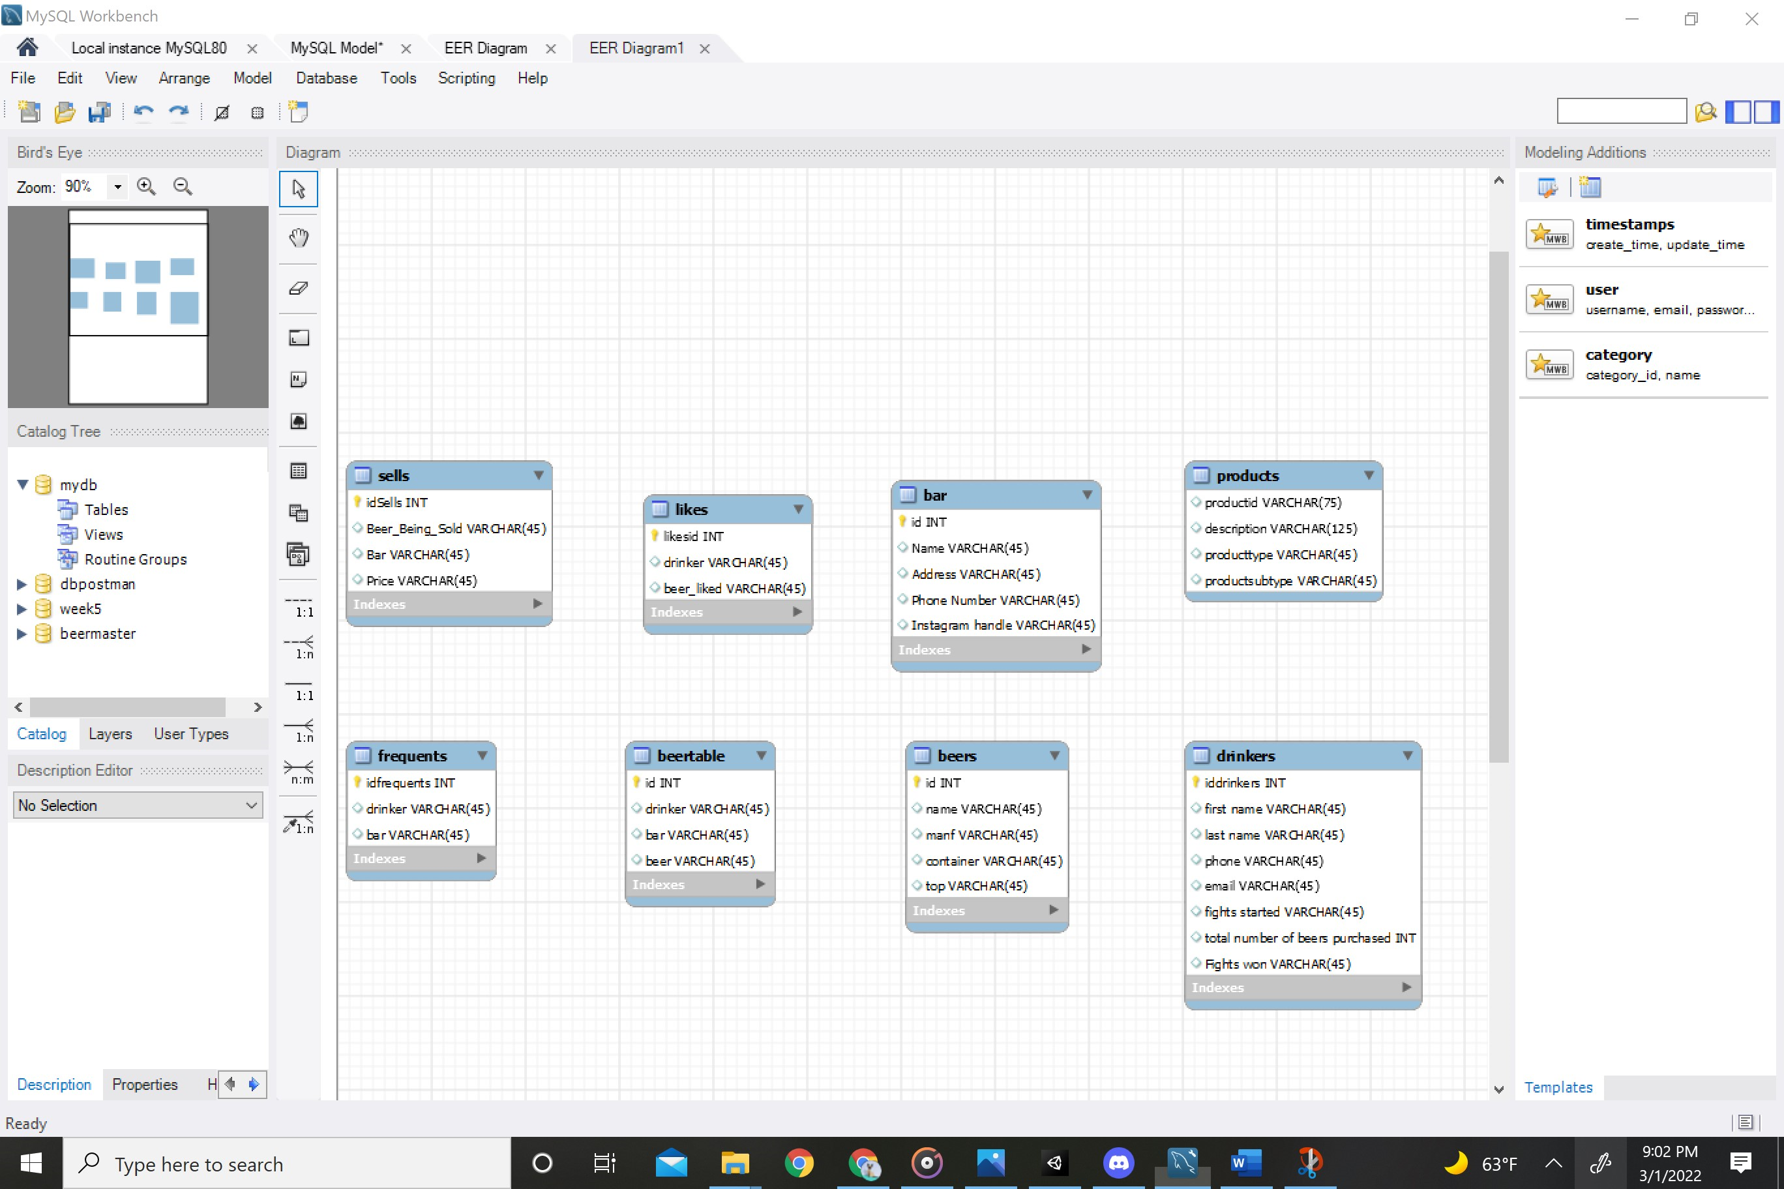

Week 5 Reverse Engineering

Dpostman Reverse Engineeing

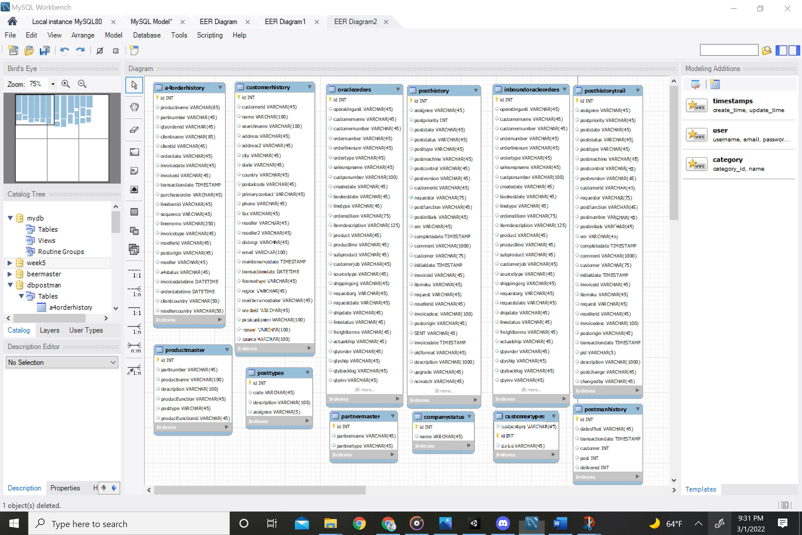

Relationship tables

A4OrderHistory

CustomerHistory

Posthistory

Inboundoracleorders

Posthistorytrail

Posttypes

Contactmaster

Processstatus

Postmanhistory

Customers

Oracleorders

A4postorders

Inboundoraclecustomers

Atomic Tables

Asignees

Partnermaster

Companystatus

customertypes

Customer Anomalies

Processstates

Custom features

Countries

Configuration

Postformats

Addressmaster

Productmaster

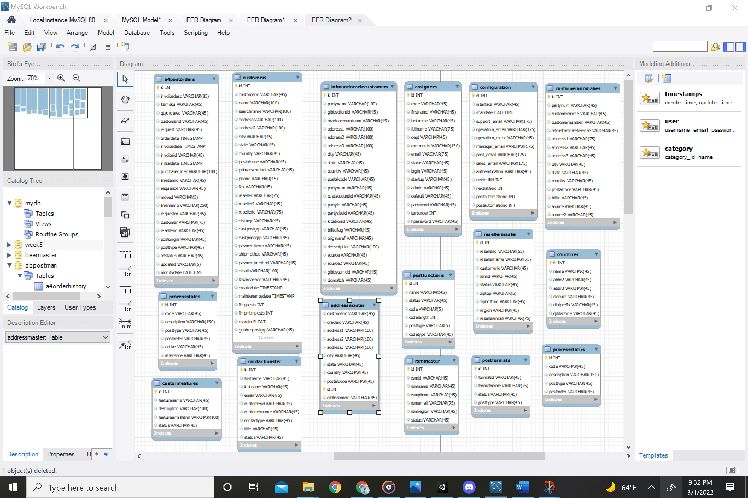

Week 5

